|  |
| --- |
| http://upload.wikimedia.org/wikipedia/commons/e/e3/Queen_Victoria_by_Bassano.jpg |

**VICTORIAN ERA (1837-1901)**

* 1837: Victoria became the queen.

1901: She died.

* Industrial Revolution created economic and social changes.

A lot of people migrated to industrial towns.

They lived in urban slums.

The population grew.

Urban poverty started.

Child labor started.

* British manufacture + trade + financial sector

Rail network

British power overseas(British Empire)

The world’s first urban and industrialized society

* Middle class became important.
* Conflict between Church & science / faith & rationalism / humanistic values & moral values / poverty & wealth
* Very strict code of conduct: People obeyed the social rules.
* It was the Age of Improvement.

Scientific inventions and discoveries: Alexander Graham Bell - Louis Pasteur - Marie

Charles Darwin: Theory of Evolution

On the Origins of Species

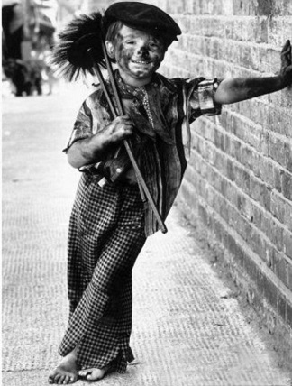 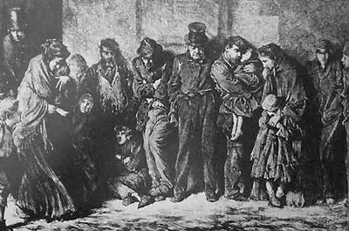

|  |
| --- |
| **VICTORIAN LITERATURE**   * The Golden Age of English Literature * Novel became important: The Age of Novel   Women authors   * Periodicals and newpapers * Writers and poets wrote for the middle class, not the aristocrats. And the middle class loved reading.   **POETRY** |

* **Elegy**: a sad poem, especially for a dead person

***Alfred Lord Tennyson***: He retold classical myths. His poems were melancholic.

– **In Memoriam**: for his best friend Arthur Henry Hallam

*‘Tis better to have loved and lost,*

*Than never to have loved at all’*

* **Dramatic monologue**: a poem (An individual character speaks.)

We see the hearth and mind of the character.

– **Ulysses**: The Ancient Greek Hero is bored with his country, Ithaca and wants to explore the world.

*‘It little profits that an idle king,  
By this still hearth, among these barren crags,  
Match'd with an aged wife, I mete and dole  
Unequal laws unto a savage race,  
That hoard, and sleep, and feed, and know not me.*

*Faydası az başıboş bir kralım,  
Kendisi gibi yaşlı bir hanımla eşlenmiş,  
Bu kıpırdamayan ocağın başında, kıraç yalçın kayaların arasında  
Ölçüp biçip eşit olmayan kanunlar dağıtırım,  
İstif yapan, uyuyan ve kendini doyuran, ve benden haberi bile olmayan,  
Yabani bir ırkın üzerine.*

**NOVEL**

* Moral purpose
* Truth – justice – love – brotherhood
* Class hierarchy – traditional domestic roles of women
* Conflict between powerful people and laborers+poor people
* Conflict between country and city life
* Deterioration of rural lifestyle

**WORKS**

* ***Charles Dickens***: He wrote about social issues of the time.

**Great Expectations**: growth of the orphan, Pip

conflict between rural and urban England

no good education for the lower classes

immorality of high class

**Oliver Twist** - **David Copperfield** - **A Tale of Two Cities**

* ***Bronte Sisters***: Emily Bronte-Wuthering Heights

Charlotte Bronte: Jane Eyre

Anne Bronte: Agnes Grey

Feminism / Dependence on men / Unemployment for women / Independence

**Wuthering Heights**: Passionate Heathcliff loves Catherine Earnshaw. But she doesnt’t want to marry him because he is a gypsy. He leaves home and Catherine marries Edgar Linton. After 3 years, Heathcliff returns and takes revenge from everyone.

**Jane Eyre**: Jane is a poor and unbeautiful girl. Her cruel aunt brings up her and sents her to a miserable school. Then she teaches the daugter of Mr. Rochester. Rochester falls in love with Jane but he is married to a mad woman. Jane laerns this and leaves Rochester. The mad wife burns the house. Mr.

Rochester tries to save her but she dies and Rochester goes blind. When Jane learns everything, she

returns and marries him.

Themes in Jane Eyre: Morality – God and Religion – Social Classes – Gender – Feminism

* ***Thomas Hardy***: **Tess of the D’Urbervilles**

Tess is a 16 year-old and pretty girl. She is raped by Alec D’Urberville and she has a baby. But her son ‘Sorrow’ dies soon. Then she marries Angel Clare. But when he learns her past, he leaves her and goes to Brazil. Tess returns near her family and sees Alec again. He wants to marry her but she doesn’t. He says Angel will never come. Tess marries him for her family. But one day Angel returns and sees Tess is married. Tess gets angry with Alec because he told lie to her and she kills her. Tess and Angel escape but Tess is found and executed. Angel marries with Tess’ sister because Tess wants this.