A NEW DAY HAS COME
by CELINE DION

Grammar: Present Perfect, Past Tenses review
‘A New Day Has Come’ is the lead single from Céline Dion's comeback album A New Day Has Come, released on March 11, 2002.
The song was written by Aldo Nova and Stephan Moccio.
‘A New Day Has Come’ was very successful around the world. On the U.S. Hot Adult Contemporary Tracks, the song stayed on top twenty-one weeks.

Level: intermediate, upper-intermediate
♫ CD track 1
Teacher’s notes
1. Beforehand, write on the board: angel, miracle, fear, light, to make it through, boy, soul, to shed a tear, to hold on. Tell the students that they are going to listen to a song called A New Day Has Come. The words on the board were taken from it. Be sure that your students understand them. Offer your group to predict this song is about.
2. Play the song and then check the general understanding.
3. Give out the worksheets. Let the students read and ask for the meaning of unknown words. Play the song again and do the first task. Students check their answers with their partners and then the pairs discuss them in an open group.
4. Do ex. 2.
5. Tell your students that the changes between then and now are also implicated into the tenses. Ask them what tenses are used in lines 6 – 13 (Past Simple and Past Continuous). First, compare them to the lines 24 – 27 (Past Simple vs Present Simple). Then pay attention to the lines 14 – 23 (Present Simple, Present Continuous and Present Perfect). Why has the things changed so dramatically? Because ‘a new day has come’, the girl has met a boy she loves… All the changes referring to the very moment in present are expressed with a help of The Present Perfect Tense. Elicit / explain the meaning and usage of this tense. Ask your students to find one more example of it (I’ve been touched… - Present Perfect Passive).
Lyrics and answers
Ex. 1.

A new day has come
A new day has come
I was waiting for so long
For a miracle to come
Everyone told me to be strong
Hold on and don't shed a tear
Through the darkness and good times
I knew I'd make it through
And the world thought I had it all
But I was waiting for you
Chorus:
Hush, now
I see a light in the sky
Oh, it's almost blinding me
I can't believe I've been touched by an angel with love
Let the rain come down and wash away my tears
Let it fill my soul and drown my fears
Let it shatter the walls for a new sun
A new day has come
A new day has come
Where there was dark now there's light
Where there was pain now there's joy
Where there was weakness I found my strength
All in the eyes of a boy
Chorus.
Let the rain come down and wash away my tears
Let it fill my soul and drown my fears
Let it shatter the walls for a new sun
A new day has come
Repeat the chorus and fade

Ex. 2. Then – now, dark – light, weakness – strength, pain – joy

A NEW DAY HAS COME
by CELINE DION
1. Read the text. There are five wrong words in it. Listen and correct them.
A new day has come
A new day has come
I was waiting for so long
For a miracle to come
Everyone told me to be weak
Hold on and don't shed a tear
Through the darkness and bad times
I knew I'd make it through
And the world thought I had it all
But I was waiting for you
Chorus:
Hush, now
I see a light in the night
Oh, it's almost blinding me
I can't believe I've been touched by an angel with love
Let the rain come down and wash away my tears
Let it fill my soul and drown my fears
Let it shatter the walls for a new sun
A new day has come
A new day has come
Where there was dark now there's light
Where there was pain now there's joy
Where there was weakness I lost my strength
All in the heart of a boy
Chorus.
Let the rain come down and wash away my tears
Let it fill my soul and drown my fears
Let it shatter the walls for a new sun
A new day has come
Repeat the chorus and fade
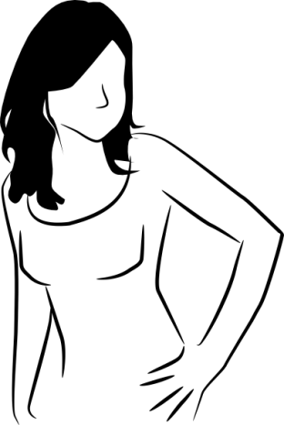
2. Find the opposites in the text.
then _____________
dark _____________
weakness _____________
pain _____________

BUS STOP
by THE HOLLIES

Грамматика: способы выражения прошедшего времени: употребление would

Level: intermediate, upper-intermediate
‘Bus Stop’ is a song recorded and released as a single by the British pop band The Hollies. It became a hit in 1966, reaching #5 in the UK Singles Chart. It was the Hollies' first US top ten hit, reaching #5 on the Billboard charts in September 1966.
It was written by UK songwriter Graham Gouldman, who said the idea for the song had come while he was riding home from work on a bus. The opening lines were written by his father, playwright Hyme Gouldman.
♫ CD track 2
Teacher’s notes
1. Bring a picture of an umbrella. Ask your students to make some short stories about this object. After listening to some stories ask if an umbrella can be involved in a love story.
2. Give out the worksheets. Students should match the words from the ex. 1.
3. Explain that these words were taken from a song called ‘Bus Stop’. You may show a picture of an English bus stop (of an old one is more preferable). Ask students to guess how could they be joined together. What is this song about?
4. Play the song. Let the students check their ideas.
5. Ask some questions. Is their romance over? - No, it isn’t. ‘Someday my name and hers are going to be the same’. How did it all begin? Because of what? - An umbrella. So, he remembers how it all began. What verb forms are used? Give some examples. Is refrain about the past or the future? - Mostly about the past (except for the last line).
5. Ask your students which word is omitted twice. Play the song and let them write in the word would. Point that she’d shop = she would shop
6. Explain / elicit the usage of would for the past habits.
Lyrics and answers
Ex. 1. 1f, 2d, 3a, 4b, 5c, 6e, 7g
Ex. 2.

Bus stop, wet day, she's there I say
Please share my umbrella
Bus stop, bus go, she stays love grows
Under my umbrella
All that summer we enjoyed it
Wind and rain and shine
That umbrella we employed it
By August she was mine

{Refrain}
Every morning I would see her waiting at the stop
Sometimes she'd shop and she would show me what she bought
All the people stared as if we were both quite insane
Someday my name and hers are going to be the same

That's the way the whole thing started
Silly, but it's true
Thinking of a sweet romance
Beginning in a queue
Came the sun, the ice was melting
No more sheltering, now
Nice to think that that umbrella
Led me to a vow

{Refrain}
Repeat the 1st verse

BUS STOP
by THE HOLLIES
1. Match the words.
1) shelter a) love
2) insane b) line
3) romance c) look very attentively
4) queue d) crazy
5) stare e) serious promise (e. g. during the wedding)
6) vow f) protected place
7) umbrella g) a thing protecting you against rain or hot sun

2. Listen again. What word is omitted twice?
Bus stop, wet day, she's there I say
Please share my umbrella
Bus stop, bus go, she stays love grows
Under my umbrella
All that summer we enjoyed it
Wind and rain and shine
That umbrella we employed it
By August she was mine

{Refrain}
Every morning I _________ see her waiting at the stop
Sometimes she'd shop and she __________ show me what she bought
All the people stared as if we were both quite insane
Someday my name and hers are going to be the same

That's the way the whole thing started
Silly, but it's true
Thinking of a sweet romance
Beginning in a queue
Came the sun, the ice was melting
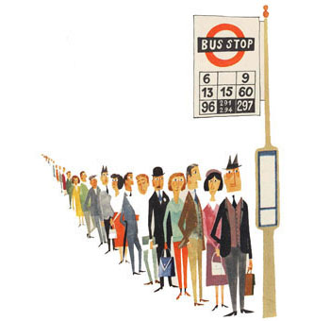
No more sheltering, now
Nice to think that that umbrella
Led me to a vow

{Refrain}
Repeat the 1st verse

EL CONDOR PASA (IF I COULD)
by SIMON AND GARFUNKEL

Грамматика: условные предложения

Level: intermediate
‘El Cóndor Pasa’ (Flight of the Condor) is a song from the zarzuela (Spanish lyric-dramatic genre) El Cóndor Pasa by the Peruvian composer Daniel Alomía Robles written in 1913 and based on traditional Andean folk tunes.
It is possibly the best-known Peruvian song worldwide due to a cover version by Simon & Garfunkel in 1970 on their Bridge Over Troubled Water album. This cover version is called El Condor Pasa (If I Could). Paul Simon used the instrumental version of Los Incas as the basic-track and wrote entirely new, unrelated lyrics.

Лексика: природные объекты, антонимы
♫ CD track 3
Teacher’s notes
1. Tell the students that they are going to listen to a song based on a (Peruvian) melody called El Condor Pasa (Flight Of The Condor). Ask them to write out more ‘nature’ words (animals, places, objects) while listening. Play the song. Possible answers: sparrow, snail, swan, ground, forest, the earth…
2. Now, let them practice ex. 1. Check the answers.
3. Do ex. 2. Play the song again.
4. Tel the group that this piece has another English name, which is not a literal translation. Ask them to guess it (If I Could).
5. Ask a question (it might be written on the board), ‘If you could chose how would you rather call it? Would you remain this name or give another one?’ While answering elicit the structure (If I could chose) I’d rather call it / I would call it… (you may also write it as a prompt).
6. Follow up. Explain to the students a construction of the lyrics. And ask them to write their own text using opposites and I’d rather structure.
Lyrics and answers
Ex. 1. 1) nail, 2) forest, 3) hammer, 4) sparrow, 5) snail, 6) street
Ex. 2. Forest – street, sparrow – snail, hammer – nail.
Ex. 3.
I'd rather be a sparrow¹ than a snail²
Yes I would, if I could, I surely would
I'd rather be a hammer³ than a nail⁴
Yes I would, if I only could, I surely would
Away, I'd rather sail away
Like a swan that's here and gone
A man gets tied up to the ground
He gives the world it's saddest sound
Its saddest sound
I'd rather be a forest⁵ than a street⁶
Yes I would, if I could, I surely would
I'd rather feel the earth beneath my feet
Yes I would, if I only could, I surely would

EL CONDOR PASA (IF I COULD)
by SIMON AND GARFUNKEL
1. Write the words from the box.
Forest, sparrow, nail, street, hammer, snail, forest

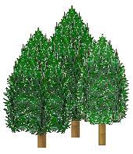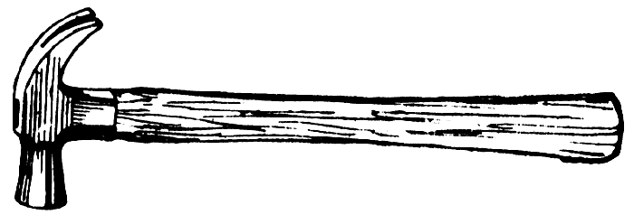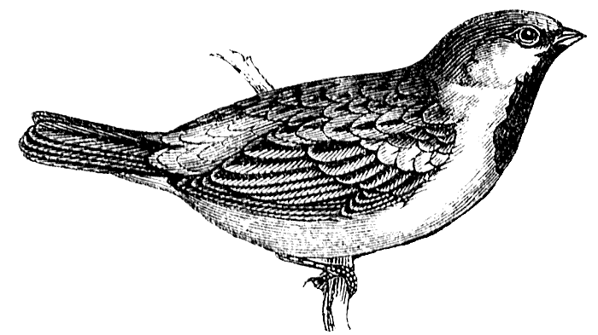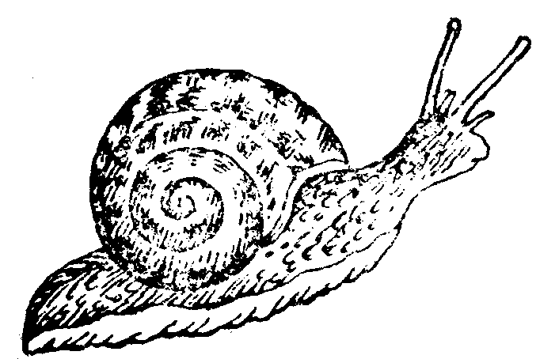
a)_______ b)_______ c)_______ d)_______ e)_____ f)_______

2. Match the words which are thought to be the opposites.
forest snail
sparrow nail
hammer street

3. Put the words for ex. 1 into this text. Listen and check.
I'd rather be a ________¹ than a _________²
Yes I would, if I could, I surely would
I'd rather be a _________³ than a ________⁴
Yes I would, if I only could, I surely would
Away, I'd rather sail away
Like a swan that's here and gone
A man gets tied up to the ground
He gives the world it's saddest sound
Its saddest sound
I'd rather be a __________⁵ than a ___________⁶
Yes I would, if I could, I surely would
I'd rather feel the earth beneath my feet
Yes I would, if I only could, I surely would

4. Think of some opposites and try to write a similar poem using I’d rather / If I could / I would.

_________________________________________
_________________________________________
_________________________________________
_________________________________________
_________________________________________
_________________________________________
_________________________________________

HOUSE
by ELTON JOHN

Грамматика и лексика: местоимения this – that (is), these – those (are); структура a place where…
‘House’ is taken from ‘Made in England’, the twenty-fifth studio album by English singer/songwriter Elton John (the author of such famous songs as Nikita, Candle In The Wind, ‘The Lion King’ soundtrack etc), released in 1995. An interesting peculiarity is that, much unlike his previous works, and with the exception of the title track, all of the album's songs have one-word titles.

Level: начальный
♫ CD track 4
Teacher’s notes
1. Bring a picture of a house (room). Refresh the usage of this – that, these – those by showing and naming the objects.
2. Tell your students to concentrate on the beginnings of the lines and fill in the gaps marked with letters with proper pronouns. Play the song. Check the answers.
3. Tell your students to concentrate on the endings of the lines and fill in the gaps marked with numbers with the words given. Play the song. First let the students check their answers with their partners. Then check.
4. Then let your students practice in showing and naming some objects using the structure This is a_____ / That is a_____ / These are the______ / Those are the_______.
5. Follow up. Pair / Group work. One student thinks of an object and describes it using where. This is a room (place, thing) where I ______ (eat, sleep, relax). The second student should guess it.
6. You may also elicit the difference between ‘It belongs to me’ and ‘They belong to me’.
Lyrics and answers

This is my house¹
This is where I live²
That is the winter
Those are the trees³
I can hear them breathe
This is my bed⁴
This is where I sleep⁵
That was the dark
Those are my dreams
they belong to me
This is my floor⁶
This is where I lie
This is a square room⁷
That was a bright light
Theseª are not my eyes
What is my soul?
Where is my tired heart?
That^{b} is the question
Where is the answer?
Inside my house
And I sit by the window⁸
And I wish I was rain
I want to fall from the sky
I want to get wet all over the rain
'Cause this is my house⁹
It belongs to me
Inside my head
It's all that's left
This^{c} is my house
This^{d} is my bed
This is where I sleep
That^{e} was the dark
Those^{f} are my dreams
They belong to me
This is my house
This is my house
This is my house
Yeah this is my house
This is my house
This is my house
This is my house

HOUSE
by ELTON JOHN
1. Listen to the song and fill in the gaps with letters in the beginning of the lines. Write this, that, these or those.
2. Listen to the song one more time and fill in the gaps with numbers in the endings of the lines. Write the words from the box.
Floor, house (*2), live, window, trees, room, bed. sleep

This is my ____________¹
This is where I _________²
That is the winter
Those are the ________³
I can hear them breathe
This is my ______⁴
This is where I ______⁵
That was the dark
Those are my dreams
they belong to me
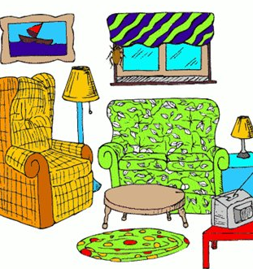
This is my _________⁶
This is where I lie
This is a square ________⁷
That was a bright light
________ª are not my eyes
What is my soul?
Where is my tired heart?
______^{b} is the question
Where is the answer?
Inside my house
And I sit by the _________⁸
And I wish I was rain
I want to fall from the sky
I want to get wet all over the rain
'Cause this is my _______⁹
It belongs to me
Inside my head
It's all that's left
__________^{c} my house
_________^{d} my bed
This is where I sleep
_________^{e} was the dark
_________^{f} are my dreams
They belong to me
This is my house
This is my house
This is my house
Yeah this is my house
This is my house
This is my house
This is my house

LAZING ON A SUNDAY AFTERNOON
by QUEEN

Грамматика: Future forms (Simple and Continuous), article the, prepositions
‘Lazing on a Sunday Afternoon’ is a song from ‘A Night at the Opera’ the fourth album by English rock group Queen, released in November 1975. At the time of its release, it was the most expensive album ever recorded. A Night at the Opera has been consistently voted by the public and cited by music publications as one of Queen's finest works, and has frequently been described as one of the greatest albums ever recorded.
‘Lazing on a Sunday Afternoon’ is a song by the group singer Mercury. He played piano and did all of the vocals. The lead vocal was sung in studio, produced through headphones elsewhere in the studio in a tin bucket. A microphone picked up the sound from the bucket, which gives it a hollow "megaphone" sound. The guitar solo is also reported to have been recorded on the vocal track, as there were no more tracks to record on.

Лексика: phrasal verbs

Level: intermediate
♫ CD track 5
Teacher’s notes
1. Write out and pre-teach / refresh the words and phrases: honeymoon, bound to be proposal, ordinary guy.
2. Ask your students the following questions. The song is called ‘Lazing On A Sunday Afternoon’. Why do you think ‘lazing’? What do ordinary people do during the week?
3. Now ask the students to listen to the song and say if the character is ‘an ordinary guy’? Why (not)?
4. Do the worksheet tasks.
Lyrics and answers
Ex. 1
I go out to work on a Monday morning
Tuesday I go off to honeymoon
I'll be back again before it's time for Sunny-down,
I'll be lazing on a Sunday afternoon
Bicycling on every Wednesday evening
Thursday I go waltzing to the Zoo
I come from London town, I'm just an ordinary guy,
Fridays I go painting in the Louvre
I'm bound to be proposing on a Saturday night (There he goes again)
I'll be lazing on a Sunday
lazing on a Sunday
lazing on a Sunday afternoon.
Ex. 2
1) Be back 2) go out 3) go off 4) come from

LAZING ON A SUNDAY AFTERNOON
by QUEEN
1. Fill in the gaps.
On, the, ’m, ’ll, the

I go out to work ____ a Monday morning
Tuesday I go off to honeymoon
I'____ be back again before it's time for Sunny-down,
I'____ be lazing ____ a Sunday afternoon
Bicycling ____ every Wednesday evening
Thursday I go waltzing to ____ Zoo
I come from London town, I'___ just an ordinary guy,
Fridays I go painting in _____ Louvre
I'm bound to be proposing ____ a Saturday night (There he goes again)
I'___ be lazing ____ a Sunday
lazing ____ a Sunday
lazing ____ a Sunday afternoon.
2. Listen to the song and check yourselves.
3. Find the phrasal verbs with the following meanings:
1) Come back____________
2) Leave (a room)__________
3) Go or run away___________
4) Be born in________________

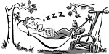

LEMON TREE
by FOOL’S GARDEN

Грамматика: Present Continuous
‘Lemon Tree’ is a song by German pop band Fool's Garden from the album Dish of the Day, which was released as a single in 1995 and became a major international hit in 1996.
The band recorded a new version of the song in prior for their 2009 release High Times - The Best of Fools Garden.

Level: начальный, intermediate
♫ CD track 6
Teacher’s notes
1. Introduce the song. Students have to decide if it is a sad or a happy one. Is a narrator happy or sad? Listen to the song and write out some activities what he’s doing now. Play the song.
2. Discuss the students’ answers. Give out the worksheets. Ask for any vocabulary difficulties. Why is the room boring? It’s another rainy Sunday afternoon. He’s waiting for his girlfriend. She isn’t coming. He’s got nothing to do. So, what is he doing? Open the brackets. Mind that there some verbs in different tenses.
3. Now, play the song again and let the students check their answers. Pay attention to the spelling (sitting, stepping). Ask your group to explain these forms.
Lyrics and answers

I'm sitting here in the boring room
It's just another rainy Sunday afternoon
I'm wasting my time
I got nothing to do
I'm hanging around
I'm waiting for you
But nothing ever happens and I wonder
I'm driving around in my car
I'm driving too fast
I'm driving too far
I'd like to change my point of view
I feel so lonely
I'm waiting for you
But nothing ever happens and I wonder
I wonder how
I wonder why
Yesterday you told me 'bout the blue blue sky
And all that I can see is just a yellow lemon-tree
I'm turning my head up and down
I'm turning turning turning turning turning around
And all that I can see is just another lemon-tree
I'm sitting here
I miss the power
I'd like to go out taking a shower
But there's a heavy cloud inside my head
I feel so tired
Put myself into bed
Well, nothing ever happens and I wonder
Isolation is not good for me
Isolation I don't want to sit on the
lemon-tree
I'm steppin' around in the desert of joy
Baby anyhow I'll get another toy
And everything will happen and you wonder
I wonder how
I wonder why
Yesterday you told me 'bout the blue blue sky
And all that I can see is just another lemon-tree
I'm turning my head up and down
I'm turning turning turning turning turning around
And all that I can see is just a yellow lemon-tree
And I wonder, wonder
I wonder how
I wonder why
Yesterday you told me 'bout the blue blue sky
And all that I can see, and all that I can see, and all that I can see
Is just a yellow lemon-tree

LEMON TREE
by FOOL’S GARDEN
Open the brackets. Write the verbs in correct form. The listen and check.

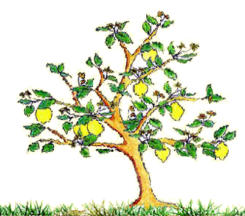
I'm ______________ (sit) here in the boring room
It's just another rainy Sunday afternoon
I'm ______________ (waist) my time
I got nothing to do
I'm _______________ (hang around)
I'm ______________ (wait) for you
But nothing ever __________ (happen) and I wonder
I'm _____________ (drive) around in my car
I'm _____________ (drive) too fast
I'm _____________ (drive) too far
I'd like to change my point of view
I feel so lonely
I'm ______________ (wait) for you
But nothing ever ____________ (happen) and I wonder
I wonder how
I wonder why
Yesterday you ___________ (tell) me 'bout the blue blue sky
And all that I can see is just a yellow lemon-tree
I'm _____________ (turn) my head up and down
I'm turning turning turning turning turning around
And all that I can see is just another lemon-tree
I'm ____________ (sit) here
I miss the power
I'd like to go out taking a shower
But there's a heavy cloud inside my head
I feel so tired
Put myself into bed
Well, nothing ever ____________ (happen) and I wonder
Isolation is not good for me
Isolation I don't want to sit on the lemon-tree
I'm ____________ (step) around in the desert of joy
Baby anyhow I'll get another toy
And everything ________________ (happen) and you wonder
I wonder how
I wonder why
Yesterday you _______ (tell) me 'bout the blue blue sky
And all that I can see, and all that I can see, and all that I can see
Is just a yellow lemon-tree



LOVE ME TENDER
by ELVIS PRESLEY

Грамматика и лексика: различные разряды местоимений, вокабуляр по теме «Любовь»
‘Love Me Tender’ is a song sung by Elvis Presley, adapted from the tune of ‘Aura Lee’, a sentimental Civil War ballad with music by George R. Poulton and words by W.W. Fosdick.
Presley performed ‘Love Me Tender’ on the The Ed Sullivan Show 9 September 1956. Soon the single and the movie, Love Me Tender, were released.
The song is credited to Presley and Vera Matson, but the principal writer of the lyrics was Ken Darby (Matson's husband).
This song was ranked #437 on Rolling Stone's list of the 500 Greatest Songs of All Time.

Level: начальный, intermediate
♫ CD track 7
Teacher’s notes
1. It is a good activity for St. Valentine Day. Draw a heart on the board. Tell your students that they are going to listen to a song. Ask them to predict what it will be about. Find out what ‘love’ vocabulary they have. Write out these words.
2. Name the song. Ask if they know it, what they think of it. Give out the worksheets.
3. Offer your students to check if there are the words you have written out in this song. Ask your class to find out how we call our love(r). Play the song. Check the answers. We call our love (My) darling / (My) dear.
4. Give out the worksheets. Let your students look them through and find more ‘love’ words (they may ask any questions about the vocabulary).
5. Explain that while the second listening they should fill in the gaps with the proper pronouns and possessive adjectives. Revise them. Play the song again.
6. Check the answers and let the students complete the task.
Lyrics and answers
Ex. 1

Love me tender,
Love me sweet,
Never let me go.
You have made my life complete,
And I love you so.
Love me tender,
Love me true,
All my dreams fulfilled.
For my darling I love you,
And I always will.
Love me tender,
Love me long,
Take me to your heart.
For it's there where I belong,
And we’ll never part.
Love me tender,
Love me dear,
Tell me you are mine.
I’ll be yours through all the years,
Till the end of time.

Ex. 2
Always – never, meet – part, reality – dream, hate – love
Ex. 3
Across
3. Dream. 4. Heart. 6. Darling.
Down
1. Your. 2. Part. 5. Always.

LOVE ME TENDER
by ELVIS PRESLEY
1. Listen to the song and fill in the gaps.
I, me, my, mine, you, your, yours, it, we

Love ____ tender, love ____ sweet,
Never let ___ go.
____ have made ____ life complete
And ____love _____ so.
Love ____ tender, love ____ true
All ____ dreams fulfill.
For ___ darling ____ love ____
And ____ always will.
Love ____ tender, love ____ long,
Take ____ to ____ heart
For __’s there where ____ belong
And ____’ll never part.
Love ____ tender, love ____ true
All ____ dreams fulfill.
For ___ darling ____ love ____
And ____ always will.
Love ___ tender, love ___ dear,
Tell ___ ___ are mine
___’ll be _____ through all the years
Till the end of time.
Love ____ tender, love ____ true
All ____ dreams fulfill.
For ___ darling ____ love ____
And ____ always will.


2. Match the opposites.
always part
meet love
reality never
hate dream
3. Use the words from the song to solve this crossword.
Across
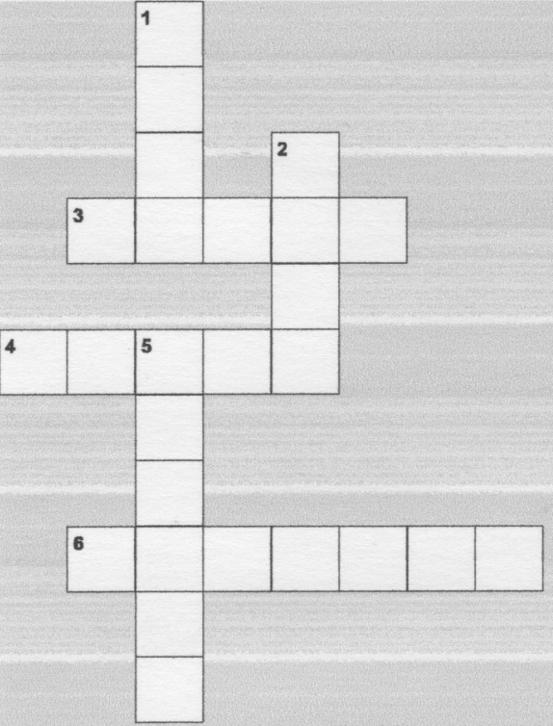
3. Something not real
4. The symbol of love.
6. Dear.

Down
1. I – my, you - …

2. ≠ meet.
5. ≠ never.

NOT ALONE ANYMORE
by TRAVELING WILBURYS

Грамматика: согласование времен, Future-in-the past

Level: intermediate, upper-intermediate
‘Not Alone Anymore’ is a song from the first album of a late 1980s supergroup Traveling Wilburys consisting of George Harrison, Jeff Lynne, Roy Orbison, Tom Petty and Bob Dylan. The band recorded two albums during the two years they were together.
‘Wilburys’ was a slang term coined by Harrison and Lynne during the recording of Cloud Nine album as a pet name for various types of equipment in the recording studio; Harrison, referring to errors caused by malfunctioning equipment, jokingly remarked to Lynne: "We'll bury 'em in the mix". The term was used again when the entire group was together.
♫ CD track 8
Teacher’s notes
1. Tell your students they are going to listen to a song ‘Not Alone’. Ask them to predict what this song is about. Is it about lost love or existing one?
2. Play the song and let the students check their answers.
3. The song is about lost love. So, the narrator is remembering their about the way they parted. He is recalling their conversations. To find out how it is expressed with language students should fill in the gaps. Give them time to work. Then play the song again. Students listen and check their answers.
4. Focus on the tenses and elicit the consequence of tenses. Encourage students to find out what I’d (1st and 2nd lines) means (I’d = I would).
Lyrics and answers
You always said¹ that I'd be² back again
That I'd come³ running to you in the end
I thought⁴ that you were⁵ on your own
And now I find you're not alone
I'll see you through the rain
Through the heartache and pain
It hurts like never before
You're not alone any more
You always said⁶ that I would know⁷ someday
Just how it feels when your love walks away
I let you down, I let you go
I lost you, how was I to know
I'll see you through the rain
Through the heartache and pain
It hurts like never before
You're not alone any more
I never knew⁸ I could⁹ feel this way
I never could see past yesterday
You feel that everything is gone
I feel it too, you're not alone
I'll see you through the rain
Every heartache and pain
It hurts like never before
You're not alone, you're not alone
You're not alone any more, any more, any more

NOT ALONE
by TRAVELING WILBURYS
Fill in the gaps with the word from the box. Then listen and check your answers.
Be, said (*2), were, know, knew, could, thought, come

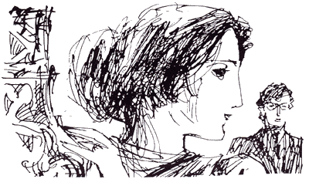
You always ________¹ that I'd _______² back again
That I'd ________³ running to you in the end
I ___________⁴ that you __________⁵ on your own
And now I find you're not alone
I'll see you through the rain
Through the heartache and pain
It hurts like never before
You're not alone any more
You always ________⁶ that I would _________⁷ someday
Just how it feels when your love walks away
I let you down, I let you go
I lost you, how was I to know
I'll see you through the rain
Through the heartache and pain
It hurts like never before
You're not alone any more
I never __________⁸ I ___________⁹ feel this way
I never could see past yesterday
You feel that everything is gone
I feel it too, you're not alone
I'll see you through the rain
Every heartache and pain
It hurts like never before
You're not alone, you're not alone
You're not alone any more, any more, any more



NOW YOU’RE GONE
by JEFF LYNNE

Грамматика: Past Simple
‘Now You’re Gone’ is a song from Armchair Theatre, the first solo album by Jeff Lynne, released in 1990. Jeff Lynne is famous for his Electric Light Orchestra and his participation in a supergroup ‘TravellingWilburys’.

Level: начальный, intermediate
♫ CD track 9
Teacher’s notes
1. Ask your students to read the title. What is this song about?
2. Let your group read the part of the song in italics. Ask them if it is about the past or the present? How did they guess? What ‘sweet memories’ can the photo bring back? Play the song and let them check.
3. Now, complete the worksheet tasks.
Lyrics and answers
Ex. 1 Be – was /were, lose – lost, want – wanted, change – changed, mean – meant, have – had.
Ex. 2
I, I was crazy about you
I, didn't want to be without you
And I, lost what I had and now you’re gone
You, you always meant the world to me
You, you never wanted much you see
And you, you changed my life but now you gone
In my heart you were the one
But now, now you’re gone
Your photograph brings back sweet memories
Something about you I don't know what it is
Your face so young the days so long
But now, you’re gone
In my heart you were the one
But now, you’re gone
Yeah now, now your gone
But now, you’re gone

NOW YOU’RE GONE
by JEFF LYNNE
1. Match the 1st and the 2nd forms.
Be meant
Lose had
Want lost
Change was / were
Mean wanted
Have changed

2. Try to fill in the gaps with the word from the box (write the verbs only if you’re sure).
Was, were(*2), changed, lost, wanted, meant, had, didn't want

I, I ________ crazy about you
I ________________ to be without you
And I ________ what I ________ and now you’re gone
You, you always _________ the world to me
You, you never _________ much you see
And you, you _________ my life but now you gone

In my heart you ________ the one
But now, now you’re gone
Your photograph brings back sweet memories
Something about you I don't know what it is
Your face so young the days so long
But now, you’re gone

In my heart you ________ the one
But now, now you’re gone

Yeah now, now you’re gone
But now, you’re gone

3. Listen to the song again and check your answers.

OLD MACDONALD
Traditional performed by FREE ABC SONGS project

Лексика: животные и звуки животных

Level: начальный
‘Old MacDonald Had a Farm’ is a children's song about a farmer named MacDonald (or McDonald) and the various animals he keeps on his farm. Each verse changes the name of the animal and its respective noise. In many versions, the song is cumulative, with the noises from all the earlier verses added to each subsequent verse.
In the 1917 book Tommy's Tunes, a collection of World War I era songs by F. T. Nettleingham, the song "Ohio (Old Macdougal Had a Farm)" has quite similar lyrics.
The Traditional Ballad Index considers the "Tommy's Tunes" version to be the earliest known version of "Old Macdonald Had a Farm.

♫ CD track 10
Teacher’s notes
1. In the beginning of the lesson practice reading and pronunciation. It is better touse the familiar words with letters oo, qu, a (e. g. book, look, cook, queen, back, black etc).
2. Ask students to name as many animals as they can (you may make a sort of a auction: the one who says the last word is a winner). Now you may play a song and ask students how many animals are mentioned. What are they?
3. Now give out the worksheets and let your students do ex. 1. Check the answers.
4. While listening the students should complete the second exercise.
5. Follow up 1. If you have time practice more animals and sound with the help of this song structure. Follow up 2. Finishing studying animals you may work on a project and create some unusual animals. Students can present their animals using this tune.
Lyrics and answers
Ex. 1 A. Dog – woof-woof. B. Cow – moo-moo. C. Duck – quack-quack. D. Sheep – baa-baa. E. Cat-meow-meow.
Ex. 2
Old Macdonald had a farm, e, i, e, i, o
and on that farm he had a duck, e, i, e, i, o
with a quack quack here, a quack quack there
here a quack, there a quack, everywhere a quack quack
Old Macdonald had a farm, e, i, e, i, o!
Old Macdonald had a farm, e, i, e, i, o
and on that farm he had a dog, e, i, e, i, o
with a woof woof here, a woof woof there
here a woof, there a woof, everywhere a woof woof
Old Macdonald had a farm, e, i, e, i, o!
Old Macdonald had a farm, e, i, e, i, o
and on that farm he had a cat, e, i, e, i, o
with a meow meow here, a meow meow there
here a meow, there a meow, everywhere a meow meow
Old Macdonald had a farm, e, i, e, i, o!
Old Macdonald had a farm, e, i, e, i, o
and on that farm he had a cow, e, i, e, i, o
with a moo moo here, a moo moo there
here a moo, there a moo, everywhere a moo moo
Old Macdonald had a farm, e, i, e, i, o!
Old Macdonald had a farm, e, i, e, i, o
and on that farm he had a sheep, e, i, e, i, o
with a baa baa here, a baa baa there
here a baa, there a baa, everywhere a baa baa
Old Macdonald had a farm, e, i, e, i, o!

OLD MACDONALD
Traditional performed by FREE ABC SONGS project
1. Name the animals. Then draw lines to the ‘words’ of animals.
Cow, sheep, duck, dog, cat


A. ___________
quack-quack


woof-woof
B. ___________
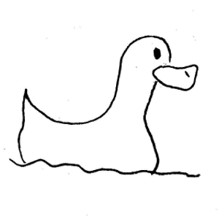
meow-meow

C. ___________
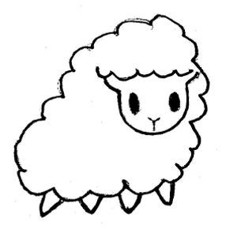
moo-moo

D. ___________
baa-baa
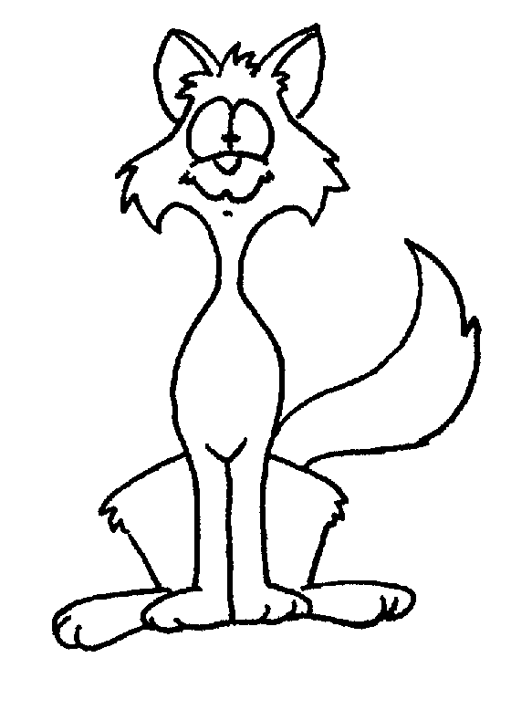

E. ___________

2. Listen to the song and write the names of the animals into the gaps.

Old Macdonald had a farm, e, i, e, i, o
and on that farm he had a _______, e, i, e, i, o
with a quack quack here, a quack quack there
here a quack, there a quack, everywhere a quack quack
Old Macdonald had a farm, e, i, e, i, o!
Old Macdonald had a farm, e, i, e, i, o
and on that farm he had a _______, e, i, e, i, o
with a woof woof here, a woof woof there
here a woof, there a woof, everywhere a woof woof
Old Macdonald had a farm, e, i, e, i, o!
Old Macdonald had a farm, e, i, e, i, o
and on that farm he had a _______, e, i, e, i, o
with a meow meow here, a meow meow there
here a meow, there a meow, everywhere a meow meow
Old Macdonald had a farm, e, i, e, i, o!
Old Macdonald had a farm, e, i, e, i, o
and on that farm he had a _______, e, i, e, i, o
with a moo moo here, a moo moo there
here a moo, there a moo, everywhere a moo moo
Old Macdonald had a farm, e, i, e, i, o!
Old Macdonald had a farm, e, i, e, i, o
and on that farm he had a _______, e, i, e, i, o
with a baa baa here, a baa baa there
here a baa, there a baa, everywhere a baa baa
Old Macdonald had a farm, e, i, e, i, o

OUR HOUSE
by CROSBY, STILLS, NASH & YOUNG

Грамматика: словообразование (переход одной части речи в другую)

Лексика: дом
‘Our House’ is a song Graham Nash, most famously recorded by Crosby, Stills, Nash & Young on their 1970 album Déjà Vu. The song refers to Nash's brief affair with Joni Mitchell at the time the group recorded the Déjà Vu album. Nash was facing the complex moral struggle between the hippy era free love mentality and the desire for a monogamous relationship. Unlike the other tracks on the album, this is the song of a man who yearns for stability in his relationship, house-ownership, and family life.

Level: начальный, intermediate
♫ CD track 11
Teacher’s notes
1. For the weaker groups write the missing words in a random order on the board and keep them covered if it is possible.
2. Tell the students that they are going to listen to a rather nice (pretty) song. Ask them to listen and make and share their own opinion. Play the record. Discuss if they liked it or not. Why?
3. Ask what it is about and refresh some ‘house’ vocabulary. Think of the things those make a living-room cozy.
4. Give out the worksheets and explain the students that they have to fill in the gaps without listening for the second time. Ask them to read the lyrics. Pay their attention to the verbs light, place, and rest (they can be nouns as well; it is a common thing in English). Ask the students’ question about unknown vocabulary. For the weaker groups uncover the world list.
5. Let the students complete the task. Discuss the results.
Lyrics and answers
I'll light the fire
You place the flowers in the vase
That you bought today
Staring at the fire
For hours and hours
While I listen to you play your love songs
All night long for me
Only for me
Come to me now
And rest your head for just five minutes
Everything is done
Such a cozy room
The windows are illuminated
By the evening sunshine through them
Fiery gems for you
Only for you
{Refrain}
Our house, is a very, very, very fine house
With two cats in the yard
Life used to be so hard
Now everything is easy 'cause of you
La la la....
{Refrain}
Repeat the first three lines

OUR HOUSE
by CROSBY, STILLS, NASH & YOUNG
Listen to the song and fill in the gaps.
I'll light the ____________¹
You place the ___________² in the ____________³
That you bought today
Staring at the ____________⁴
For hours and hours
While I listen to you play your love songs
All night long for me
Only for me

Come to me now
And rest your head for just five minutes
Everything is done
Such a cozy __________⁵
The ____________⁶ are illuminated
By the evening sunshine through them
Fiery gems for you
Only for you

{Refrain}
Our house, is a very, very, very fine house
With two ____________⁷ in the _____________⁸
Life used to be so hard
Now everything is easy 'cause of you

La la la....

{Refrain}

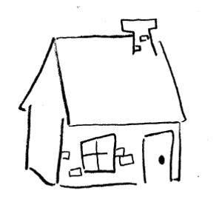
Repeat the first three lines

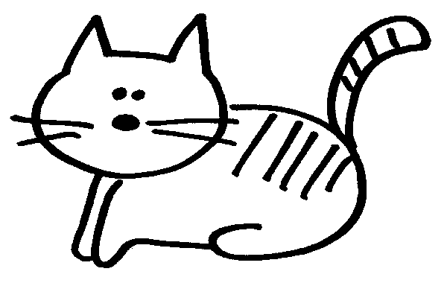

SWEET DREAMS
by EURHYTHMICS

Грамматика: Passive Voice

Лексика: материал (стекло, серебро, кожа и т. д.)

Level: intermediate
‘Sweet Dreams (Are Made of This)’ (or simply ‘Sweet Dreams’) is a song by pop music duo Eurythmics (David A. Stewart and Annie Lennox). It is notable as the song which provided the group with their breakthrough into commercial success. On Rolling Stone's The 500 Greatest Songs of All Time issue in 2003, "Sweet Dreams (Are Made of This)" was ranked number 356: it was the group's only song on the list. The lyrics of the song allude to a search for fulfillment, and the "Sweet Dreams" are the desires that motivate us.
The original recording's main instrumentation featured a sequenced analog synthesizer riff, which Stewart discovered accidentally in the studio when he played a bass track in reverse. Apart from the synthesizer, the arrangement also uses Movement Systems Drum Computer, piano in the middle eight, and Lennox's multitracked harmony vocals.

♫ CD track 12
Teacher’s notes
1. Write out and pre-teach the word abuse.
2. Tell your students they are going to listen to the song and fill in the gaps with the proper forms of the words in brackets. Play the song.
3. Discuss the difference between each pair of the Some of them sentences.
Answer
Ex. 1
Sweet dreams are made of this
Who am I to disagree?
I travel the world
And the seven seas--
Everybody's looking for something.
Some of them want to use you
Some of them want to get used by you
Some of them want to abuse you
Some of them want to be abused.
(Hold your head up--Keep your head up—Movin’ on)

Ex.2
a) a glass vase – A vase is made glass.
b) the cotton T-shirts – The T-shirts are made of cotton.
c) a leather jacket – A jacket is made of leather.
d) a silver watch – A watch is made of silver.
e) the plastic pens – The pens are made of plastic.

SWEET DREAMS
by EURHYTHMICS
1. Listen and fill in the gaps with the proper forms of the verbs in brackets.
Sweet dreams ____________ (make) of this
Who am I to disagree?
I travel the world
And the seven seas--
Everybody's looking for something.
Some of them want to ___________ (use) you
Some of them want to get _________ (use) by you
Some of them want to ___________ (abuse) you
Some of them want to ___________ (abuse).
(Hold your head up--Keep your head up--MOVIN' ON)

2. Match the objects and material. Use the word box to fill in the gaps. Then write what these objects are made of (e. g. Sweet dreams are made of this).
Cotton, silver, glass, plastic, leather

a) a ___________ A vase is made of __________________
b) the __________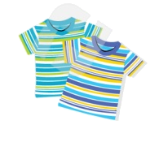 The T-shirts are made_______________
c) a____________ A jacket is________________________
d) a___________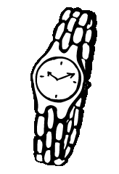 A watch__________________________
e) the __________ The______________________________
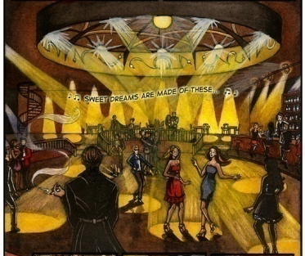

WIND OF CHANGE
by SCORPIONS

Грамматика: причастия настоящего времени
‘Wind of Change’ is a 1990 power ballad written by Klaus Meine, vocalist of the Scorpions. It appeared on their 1990 album Crazy World. The Scorpions were inspired to write this song on a visit to Moscow in 1989. The lyrics celebrate the political changes in Eastern Europe at that time – such as the Polish Round Table Agreement and fall of the Berlin Wall and the clearly imminent end of the Cold War.
The band also recorded a Russian-language version of the song, under the title «Ветер Перемен» (Veter Peremen) and a Spanish version called Vientos de Cambio.
The song is currently the 10th best-selling single of all time in Germany.

Level: intermediate
♫ CD track 13
Teacher’s notes
1. Announce the song. Ask students if they know why it is called so. Ask where the story takes place and if a narrator dreams of the wind of changes or he feels it now. Play the song.
2. Check the students’ answers.
The story takes place in Moscow, Russia (the USSR). The Moskva is the name of the river, and Gorky Park is a famous amusement park in Moscow. The narrator feels the wind of change while walking around the city.
3. Give out the worksheets. Explain that to avoid repetition in ‘Soldiers <are> passing by and they are listening to the wind of change’ the author uses participle listening. Ask your students to fill in the gaps with the Present participles (V-ing).
4. Play the song again. Then check the answers.
Lyrics and answers

I follow the Moskva
Down to Gorky Park
Listening to the wind of change
An August summer night
Soldiers passing by
Listening to the wind of change

The world is closing in
Did you ever think
That we could be so close, like brothers
The future's in the air
I can feel it everywhere
Blowing with the wind of change

Refrain 1
Take me to the magic of the moment
On a glory night
Where the children of tomorrow dream away
in the wind of change

Walking down the street
Distant memories
Are buried in the past forever
I follow the Moskva
Down to Gorky Park
Listening to the wind of change

Refrain 2
Take me to the magic of the moment
On a glory night
Where the children of tomorrow share their dreams
With you and me
Take me to the magic of the moment
On a glory night
Where the children of tomorrow dream away
in the wind of change

The wind of change
Blows straight into the face of time
Like a stormwind that will ring the freedom bell
For peace of mind
Let your balalaika sing
What my guitar wants to say
Refrain 2

WIND OF CHANGE
by SCORPIONS
Listen and fill in the gaps with the present participles (V-ing)

I follow the Moskva
Down to Gorky Park
__________ to the wind of change
An August summer night
Soldiers passing by
Listening to the wind of change

The world is closing in
Did you ever think
That we could be so close, like brothers
The future's in the air
I can feel it everywhere
__________ with the wind of change
Refrain 1
Take me to the magic of the moment
On a glory night
Where the children of tomorrow dream away
in the wind of change

___________ down the street
Distant memories
Are buried in the past forever
I follow the Moskva
Down to Gorky Park
___________ to the wind of change

Refrain 2
Take me to the magic of the moment
On a glory night
Where the children of tomorrow share their dreams
With you and me
Take me to the magic of the moment
On a glory night
Where the children of tomorrow dream away
in the wind of change

The wind of change
Blows straight into the face of time
Like a stormwind that will ring the freedom bell
For peace of mind
Let your balalaika sing
What my guitar wants to say

Refrain 2



YAKETY YAK
by THE COASTERS

Грамматика: повелительное наклонение

Лексика: обязанности, предметы быта (одежда)

Level: начальный, intermediate
‘Yakety Yak’ is a song written, produced, and arranged by Jerry Leiber and Mike Stoller for The Coasters and released on Atlantic Records in 1958, spending seven weeks as number one on List of number one rhythm and blues hits and a week as number one on the Hot 100 pop list. This song was one of a string of singles released by The Coasters between 1957 and 1959 that dominated the charts, one of the biggest performing acts of the rock and roll era.
The lyrics describe the listing of household chores to a kid, presumably a teenager, the teenager's response (yakety yak) and the parent's retort (don't talk back. The serio-comic street-smart “playlets” etched out by the songwriters were sung by the Coasters with a sly clowning humor. The screaming saxophone of King Curtis filling in hot, honking bursts in the up tempo doo-wop style.
♫ CD track 14
Teacher’s notes
1. Tell the students that they are going to listen to a song called ‘Yakety Yak’. Elicit / translate the title (blab, waffle). Write out the title and a phrase ‘Don’t talk back’. Elicit the situation. Who might say it? – A teenager and a parent. Why? They are having arguments about the chores.
2. Find out which chores your students have at home. Write some of them on the board.
3. Now complete the first exercise. Check the answers.
4. Explain the second task. Play the song.
5. Give your students time to check the answers in pairs. Then play the song again.
6. Asks students to fill in the gaps with mother’s instructions (ex. 3). Give an example with a help of a picture of scrubbing the floor. Check the answers.
7. Explain the imperatives (both positive and negative).
8. Ask students to find more imperatives.
9. Follow up. Ask your students to make a dialogue based on this song. Act it out.
Lyrics and answers
Ex. 1 a) laundry mat, b) hat, c) room, d) spending cash, e) broom, f) coat, g) trash, h) kitchen floor
Ex. 2.

Take out the papers and the ¹trash
Or you don't get no ²spending cash
If you don't scrub that ³kitchen floor
You ain't gonna rock and roll no more
Yakety yak
Don't talk back
Just finish cleaning up your ⁴room
Let's see that dust fly with that ⁵broom
Get all that garbage out of sight
Or you don't go out Friday night
Yakety yak
Don't talk back
You just put on your ⁶coat and ⁷hat
And walk yourself to the ⁸laundry mat
And when you finish doing that
Bring in the dog and put out the cat
Yakety yak
Don't talk back
Don't you give me no dirty looks
Your father's hip, he knows what cooks
Just tell your hoodlum friends outside
You ain't got time to take a ride
Yakety yak
Don't talk back
Yakety yak, yakety yak
Yakety yak, Yakety yak
Yakety yak?

Ex. 4. 1) put on your coat (and hat), 2) take out (the papers) and the trash, 3) walk (yourself)to the laundry mat, 4) bring in the dog, 5) don’t talk back.

YAKETY YAK
by THE COASTERS
1. Match the words and the pictures.
Coat, laundry mat, trash, spending cash, hat, room, kitchen floor, broom

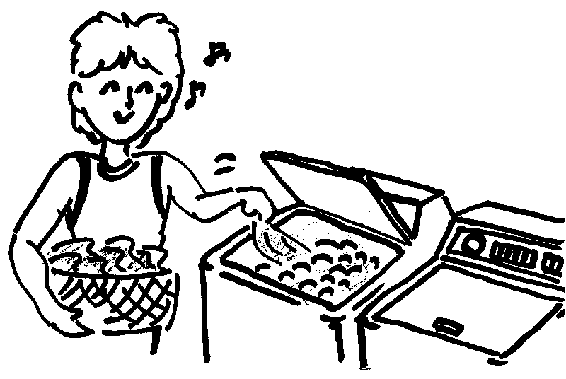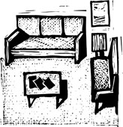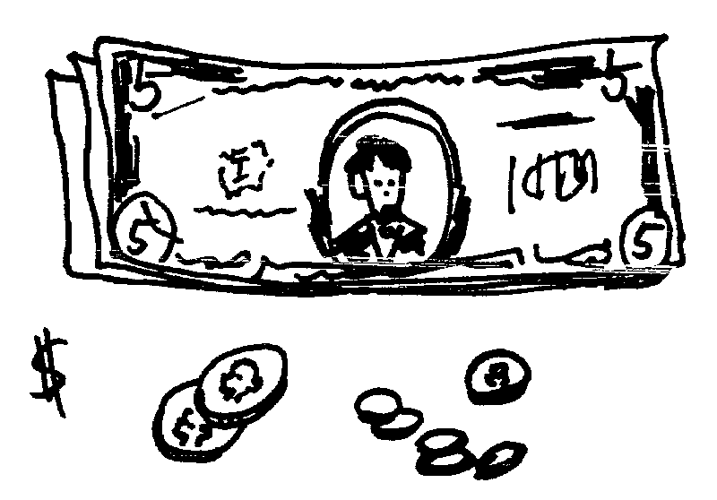
a)_____________ b)___________ c)___________ d)__________
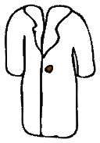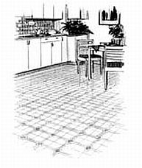
e)_____________ f)___________ g)___________ h)__________
2. Listen and fill in the gaps with the words (letters) from ex. 1.

Take out the papers and the ¹______
Or you don't get no ²_____________
If you don't scrub that ³___________
You ain't gonna rock and roll no more
Yakety yak
Don't talk back
Just finish cleaning up your ⁴_______
Let's see that dust fly with that ⁵____
Get all that garbage out of sight
Or you don't go out Friday night
Yakety yak
Don't talk back
You just put on your ⁶_____ and ⁷___
And walk yourself to the ⁸_________
And when you finish doing that
Bring in the dog and put out the cat
Yakety yak
Don't talk back
Don't you give me no dirty looks
Your father's hip, he knows what cooks
Just tell your hoodlum friends outside
You ain't got time to take a ride
Yakety yak
Don't talk back
Yakety yak, yakety yak
Yakety yak, Yakety yak
Yakety yak

3. Write instructions from the text above

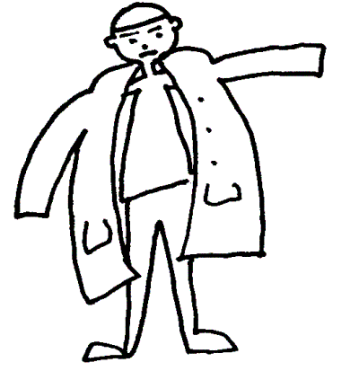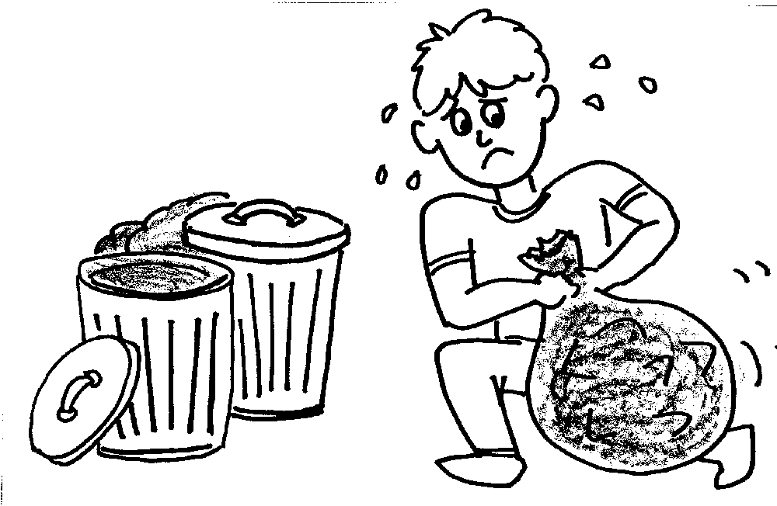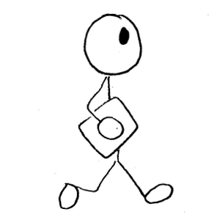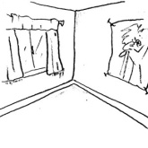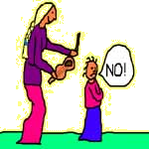
1.________ 2.____________ 3.___________ 4.__________ 5._________
________ _____________ ____________ ___________ __________

YELLOW SUBMARINE
by THE BEATLES

Грамматика: Past Simple (Present Simple review)

Лексика: природные объекты, цвета (повторение)
‘Yellow Submarine’ is a 1966 song by The Beatles (credited to Lennon/McCartney), with lead vocals by Ringo Starr. Although it had previously been released on the Revolver album, it became the title song for the 1968 animated United Artists film, also called Yellow Submarine. It is also the title for the soundtrack album to the film, released as part of The Beatles' music catalogue.
McCartney was living in Jane Asher's parents' house when he found the inspiration for the song: "I was laying in bed in the Asher's garret... I was thinking of it as a song for Ringo, which it eventually turned out to be, so I wrote it as not too rangey [too many notes] in the vocal, then started making a story, sort of an ancient mariner, telling the young kids where he'd lived. It was pretty much my song as I recall... I think John helped out. The lyrics got more and more obscure as it goes on, but the chorus, melody and verses are mine." The song began as being about different coloured submarines, but evolved to include only a yellow one.

Level: начальный, intermediate
♫ CD track 15
Teacher’s notes
1. Ask your students to read the title. Explicate (translate or show the picture) the word ‘submarine’. What do they think the song will be about? What colours will be used? What picture can they think of? Write out the words (the) sun, sea, wave and explain them or show some pictures. Play the song and let your students check their answers.
2. Students complete the first task. Check the answers and practice pronunciation.
3. Tell the students to listen to the song for the second time and fill in the gaps (ex. 2). Play the song again.
4. Optional activity. Find out what the other verb forms are. Why?
Answers
Ex. 1 Was born, told, found, sailed, lived.
Ex. 2
In the town where I was born,
Lived a man who sailed to sea,
And he told us of his life
In the land of submarines.

So we sailed up to the sun,
Till we found the sea of green,
And we lived beneath the waves
In our yellow submarine.
We all live in a yellow submarine,
Yellow submarine, yellow submarine.
And our friends are all aboard
Many more of them live next door.
And the band begins to play.
We all live in a yellow submarine,
Yellow submarine, yellow submarine.
As we live a life of ease,
Everyone of us has all we need,
Sky of blue and sea of green
In our yellow submarine.
We all live in a yellow submarine,
Yellow submarine, yellow submarine.

YELLOW SUBMARINE
by THE BEATLES
1. Write the Past Simple forms (there are two regular verbs).
To be born - ________________, tell - ____________, find - ____________, sail - ____________, live - ____________.
2. Listen to the song. Fill in the proper forms (some verbs are used more than once).
In the town where I______________,
_________ a man who _________ to sea,
And he _________ us of his life
In the land of submarines.
So we ________ up to the sun,
Till we ________ the sea of green,
And we ________ beneath the waves
In our yellow submarine.
Chorus: We all live in a yellow submarine,
Yellow submarine, yellow submarine.
And our friends are all aboard
Many more of them live next door.
And the band begins to play.
Chorus.
As we live a life of ease,
Everyone of us has all we need,
Sky of blue and sea of green
In our yellow submarine.
Chorus.
